The Report Output in APPS:
You can see the garbage under the Report Heading

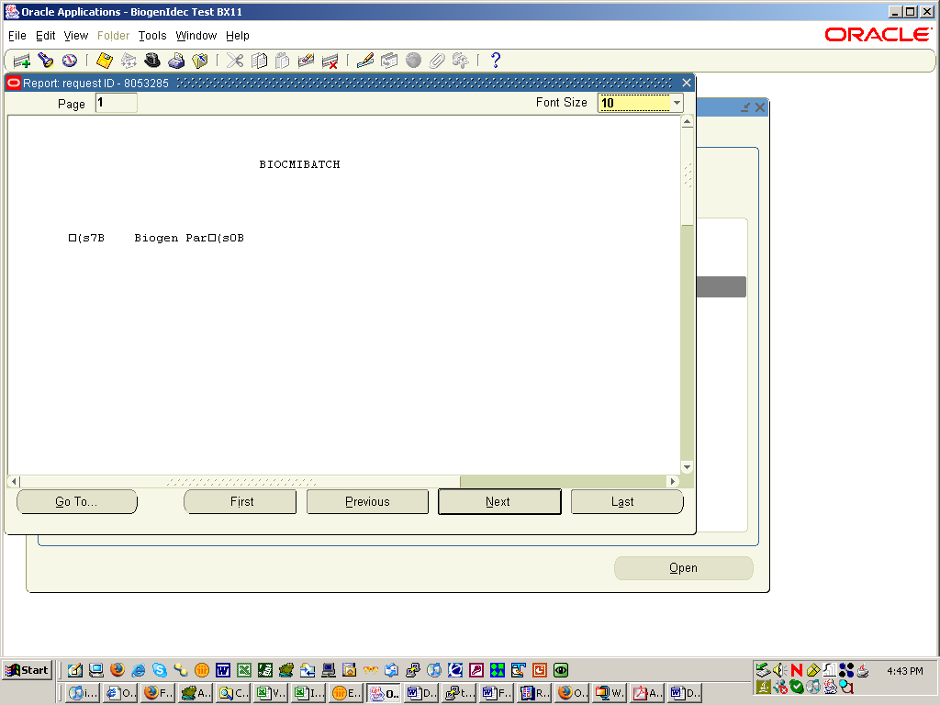

Preview of the Report in Reports Developer
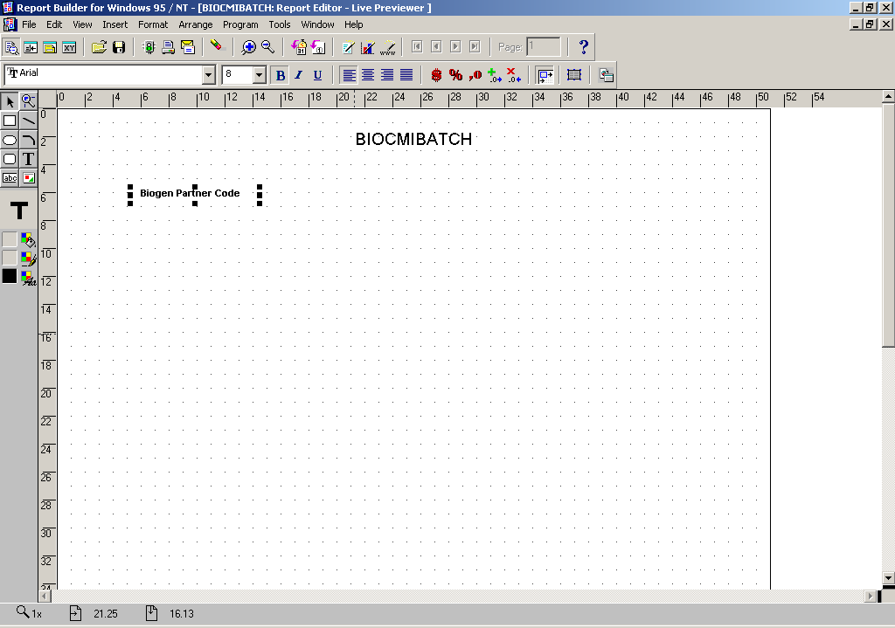

The Report Definition in APPS for the Concurrent Request

Is the Columns setting correct??

